Daniel 9:24-27
Daniel 9:24-27 | Reckoning |  | Explanation
Daniel 9:24-27 | Jewish  (Lunar-solar year of 360 days) | Julian  (Solar year of 365.25 days) | Explanation
²⁴"Seventy weeks have been decreed for your people and your holy city, to finish the transgression, to make an end of sin, to make atonement for iniquity, to bring in everlasting righteousness, to seal up vision and prophecy, and to anoint the most holy place. |  |  | • God will focus on Israel for 70 weeks (lit. "sevens"). At the end of the 70 weeks God will end sin, anoint the Messiah, and bring in everlasting righteousness.  • 70 weeks = 490 years.
²⁵"So you are to know and discern that from the issuing of a decree to restore and rebuild Jerusalem | 1 Nisan, B.C. 445 | 14 March, B.C. 445 | • Artaxerxes Longimanus (king of Persia) in the 20th year of his reign, pronounced an edict allowing Nehemiah to rebuild Jesusalem (Ne.2:1-8).
until Messiah the Prince there will be seven weeks and sixty-two weeks; it will be built again, with plaza and moat, even in times of distress. | 10 Nisan, A.D. 32 | 6 April, A.D. 32 (Sunday) | • "Messiah" is the predicted Jesus Christ (Jn.1:41; 4:25; Is.9:6; Da.8:11,25).  • The exact time this refers to is the beginning of Christ’s public ministry.  • "seven weeks"- From B.C. 445 though the 7 weeks (49 years) goes to B.C. 396, which is the closing date of Malachi’s prophecies (close of the biblical canon).  7 weeks (of years) + 62 weeks (of years) = 69 weeks  69 weeks X’s 7 years = 483 Biblical years (173,880 days)
²⁶"Then after the sixty-two weeks the Messiah will be cut off and have nothing, | 10 Nisan, A.D. 32 | 6 April, A.D. 32 (Sunday) | 173,880 days from edict to restore is the Triumphal entry of Christ.  • Christ presents Himself as the "Messiah" and is "cut off" or crucified (Lu.19:39-44).
and the people of the prince who is to come will destroy the city and the sanctuary. And its end will come with a flood; even to the end there will be war; desolations are determined. |  |  | The "people of the prince who is to come" are the people of Rome. Specifically, this is the Roman army lead by the general Titus in A.D. 70.
GAP of TIME
Since Israel rejected her Messiah, God has postponed the prophesied kingdom. A parallel postponement in Israel’s history is the 40 years in the wilderness. Israel was right at the Promised Land. They waited for the report from the 12 spies instead of believing God. If they believed God then, they would have immediately entered the Promised Land. Because of unbelief God had them wander in the wilderness for 40 years until a new generation appeared who were ready to believe God’s promises. In like manner the fulfillment of the prophesied kingdom will come to a future generation that is ready to believe their God.
²⁷"And he will make a firm covenant with the many for one week, but in the middle of the week he will put a stop to sacrifice and grain offering; and on the wing of abominations will come one who makes desolate, even until a complete destruction, one that is decreed, is poured out on the one who makes desolate." |  |  | • The 70th week begins with the "firm covenant with the many."  • The middle of the 70th week is marked by the covenant maker putting "a stop to sacrifice and grain offering". This at least assumes that during the 70th week, sacrifices will have been re-instituted.
¹ Any calculation between B.C. (Before Christ) and A.D. (Lat. Anno Domini, "in the year of our Lord") must subtract one year because there is no year 0 (B.C.) or (A.D.). That is, from B.C. 1 to A.D. 1 is not 2 years but 1 year.

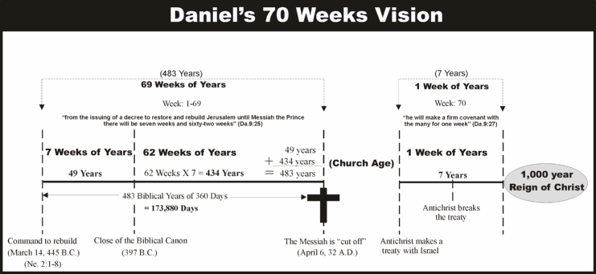

Summary
A total of 70 weeks (lit. "sevens") is what God gives to Israel to fulfill Daniel 9:24. | 70 weeks of years  = 490 years
The 70 weeks begin at the decree to restore and rebuild Jerusalem | Nisan 1, 445 B.C.  = March 14, 445 B.C.
From the decree (March 14, 445 B.C.) till the Messiah is "cut off" is 69 of the 70 weeks, with 1 week (of years) remaining. | 69 weeks =173,880 days  = April 6, 32 A.D.
There is a gap between the 69th and 70th week, which is the church age. The church age must end before the 70th week will resume. | A parenthesis or break in sequence of time  = Church age
The remaining week is future, and is commonly called the "Tribulation" period. | Future 7 year period  = The Tribulation Period

